**A picture containing clipart

Description generated with very high confidence**

Creating Modules in Puppet

DevOps Certification Training

[**support@intellipaat.com**](mailto:support@intellipaat.com)

**+91-7022374614**

**US: 1-800-216-8930(Toll Free)**

**CREATING MODULES IN PUPPET**

**Steps for Puppet Master**

**Step 1:** Create a new directory “new”, followed by the below command. Enter the required values and proceed

$ mkdir new

$ cd new

$ sudo puppet module generate intelli-new

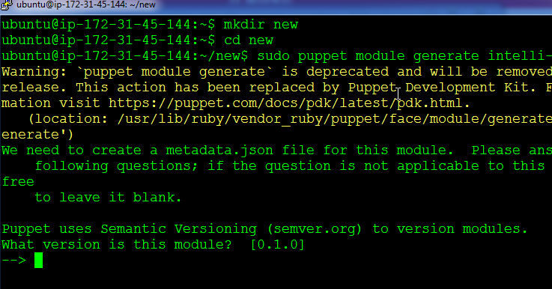

**Step 2:** You have successfully created the module. Change into the following directory ./new/new/manifests

Enter the following code in init.pp

class new{

file{'/tmp/module_test.txt':

content=> "This file is created by a module",

mode=> '0644',

}

}

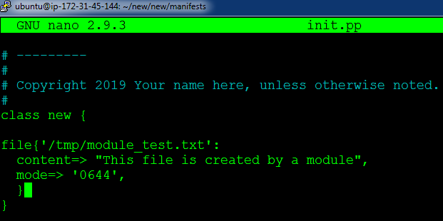

**Step 3:** Come back to the /new directory, and pass the following command:

$ sudo puppet module build new

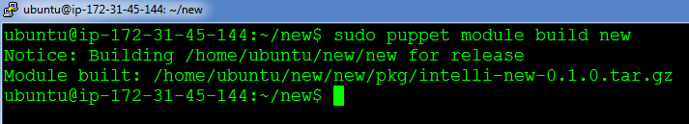

**Step 4:** Next, we will install the module by referring the tar.gz file from the last output:

$ sudo puppet module install ./new/pkg/intelli-new-0.1.0.tar.gz

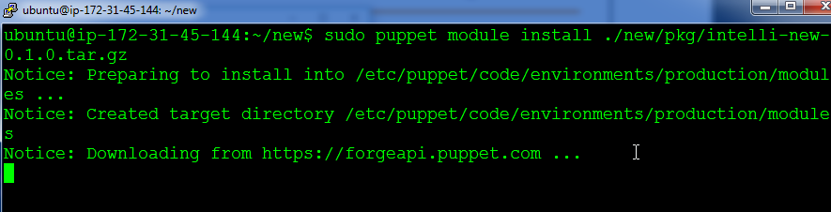

**Step 5:** Finally, go to the main manifest file in **/etc/puppet/code/environments/production/manifest/site.pp**

Finally,include the following code:

node default{

include new

}

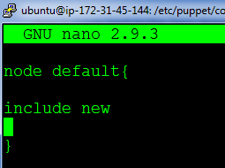

**On Puppet Agent**

**Step 1:** Execute the following command:

$ sudo puppet agent --test

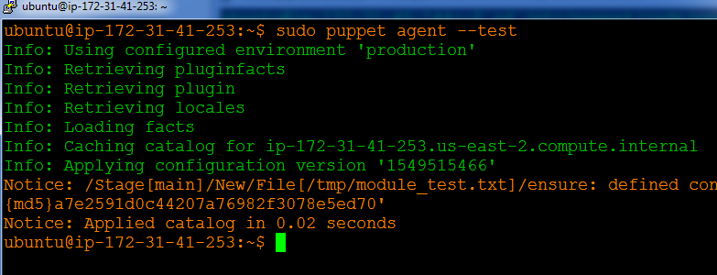

**Step 2:** Verify the configuration change by checking /tmp/module_test.txt

